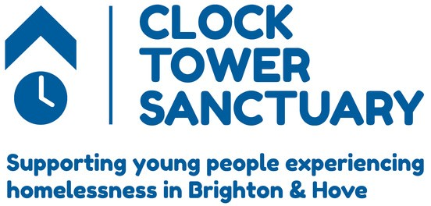

T: | 01273 722353
E | info@thects.org.uk
W | www.thects.org.uk
A: | 41-43 North Street
 | Wenlock House
 | Brighton
BN1 1RH

Refund Policy
CTS work hard to ensure that donors contributing have an easy and straight forward experience.
To comply with legal and best practice regulations set by the Charity Commission, Fundraising Regulator and the Institute of Fundraising all donations CTS receive, (including registration fees for challenge participation) are treated as irrevocable gifts and, as such, are non-refundable. Although we want to do everything we can to look after our much-needed supporters, we are unable to make a refund in the majority of cases.

